DOKUMENTASI

TC005-STEP 1:

1. Enter Email

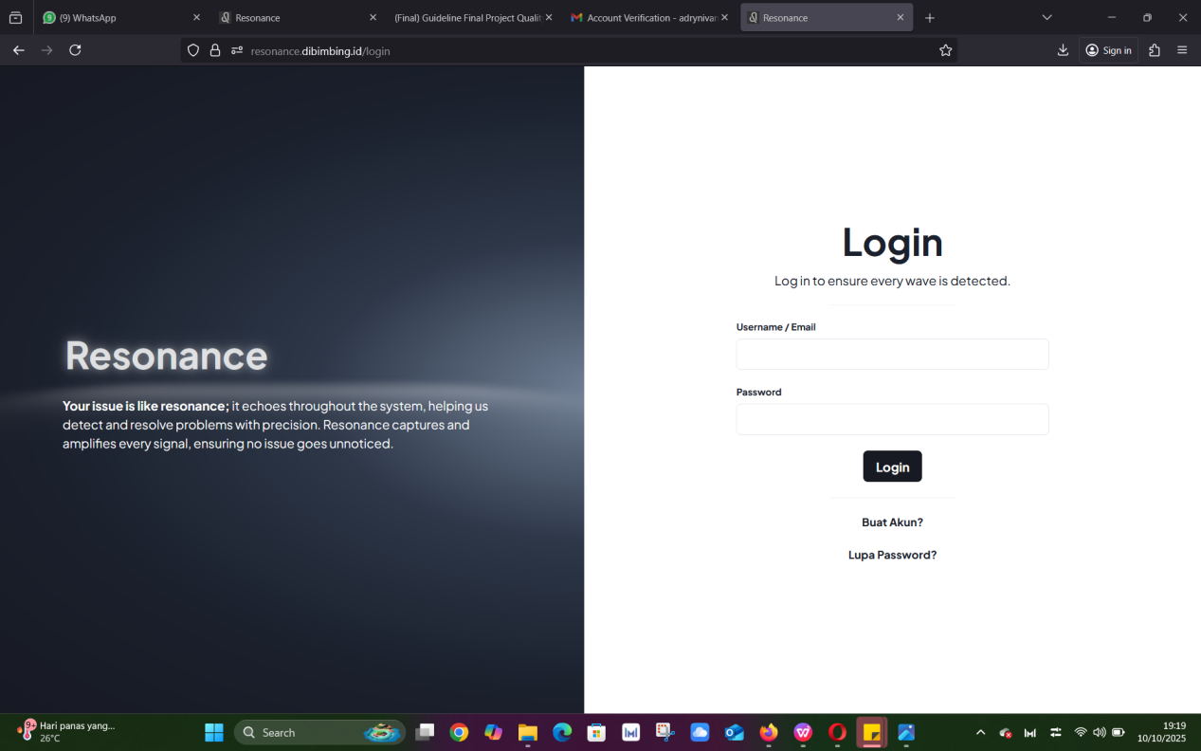

EXPECTED RESULT :

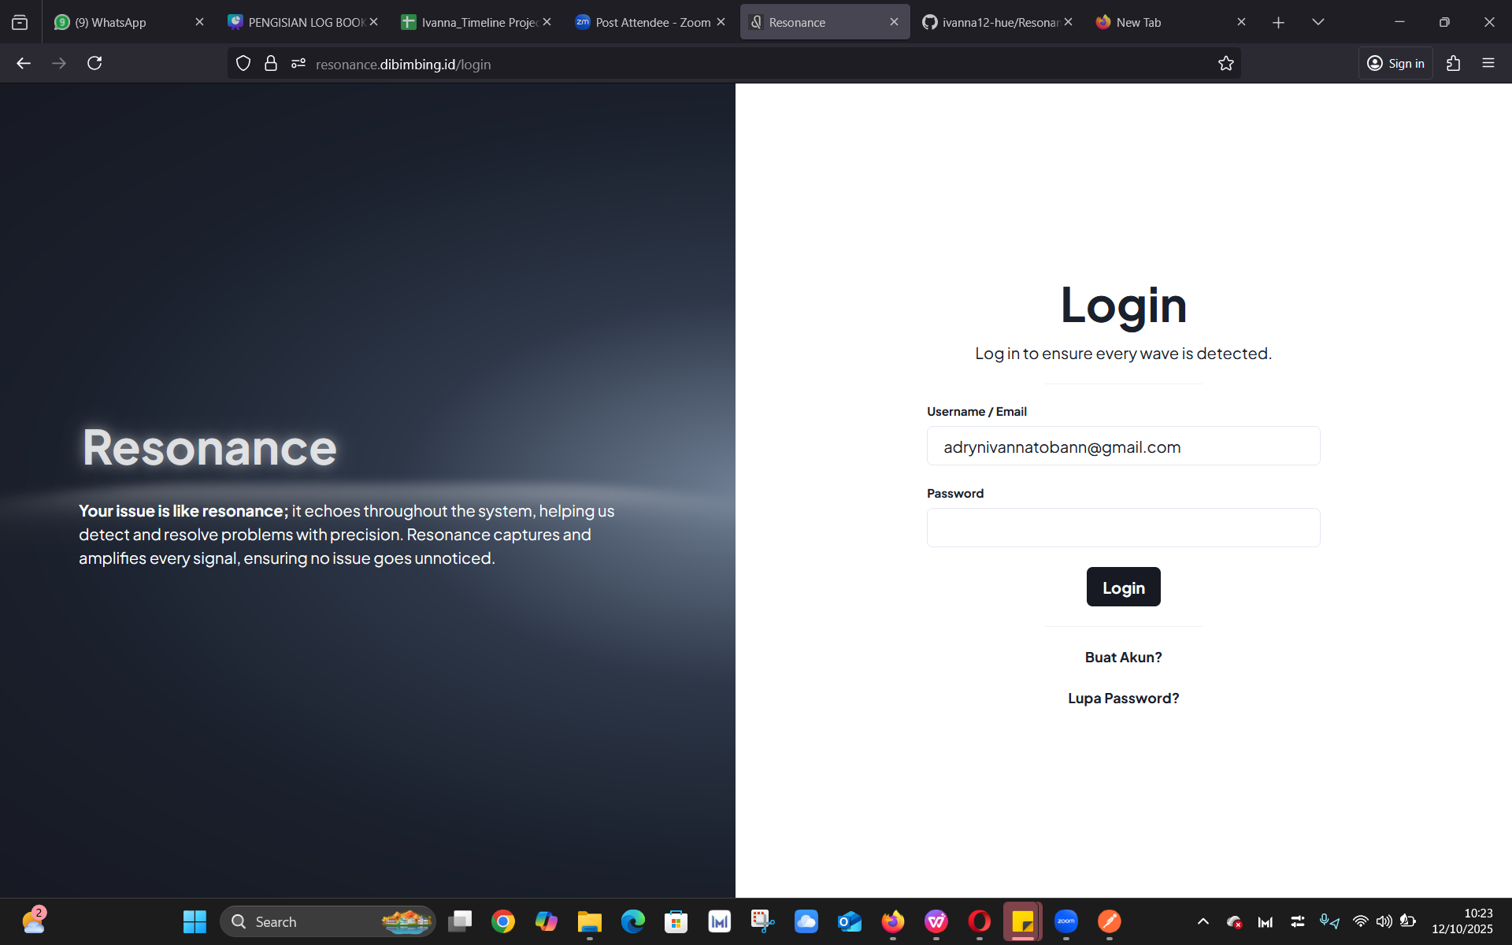

1. Enter Password



EXPECTED RESULT :

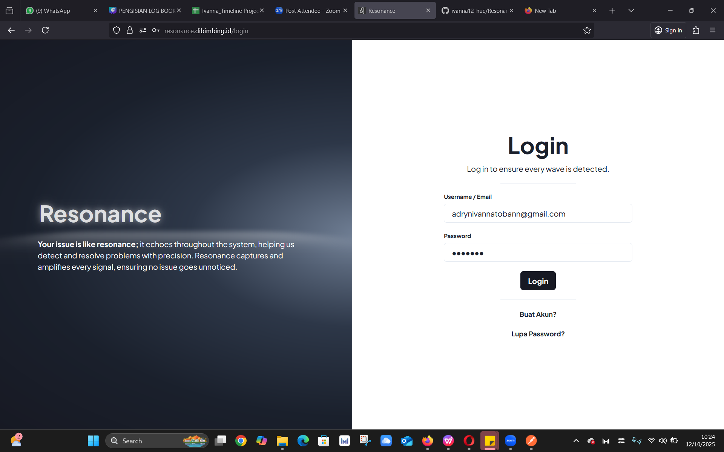

3. Click the Login button



EXPECTED RESULT : Login failed, and an “Invalid password” notification appears

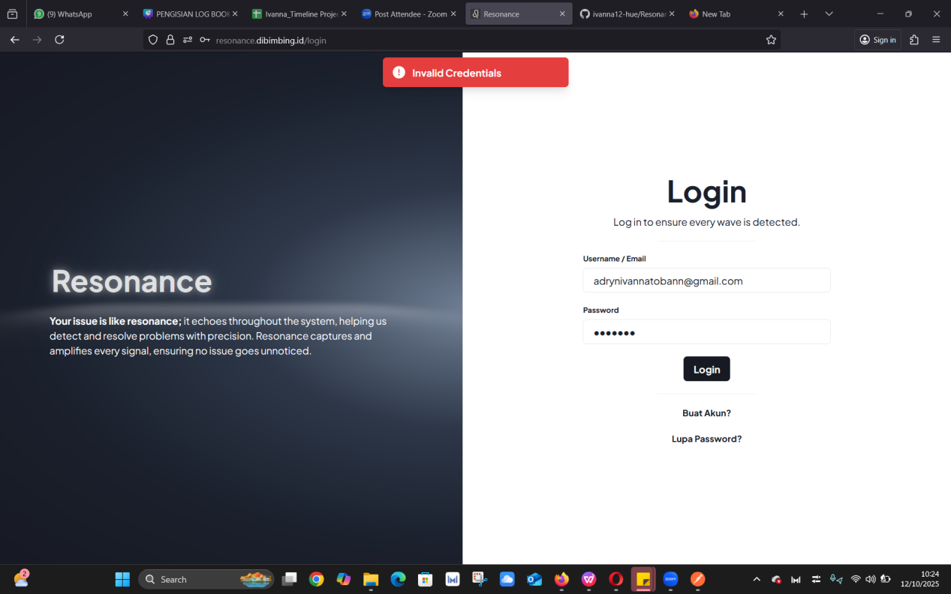

ACTUAL RESULT : The notification displayed is “Invalid Credentials”, but it should inform the user “Invalid Password” instead.